
Class XII Computer Science BOARD Project
Library Management System
Jhanvi Shankar
120214
XII-B

Contents
Objective 2
Scope 2
Book Management 2
Member Management 2
Borrowing and Returns 3
Reporting 3
Hardware and Software Requirements 3
Hardware 3
Software 3
System Design 3
Logical Data Model 4
Entity Relationships: 4
Tables & Fields for Database 5
Table Structure 6
1. Books Table Structure with Sample Data 6
2. Members Table Structure with Sample Data 7
3. Transactions Table (Join Table) Structure with Sample Data 8
4. Categories Table Structure with Sample Data 9
Sample Records: 9
Key Features Implementation 10
Business Rules 10
Validation Rules 10
Status Values (Managed in Application Logic) 11
Welcome Screen Design 11
Admin Welcome Screen 11
Member Welcome Screen 12

Objective
The project 'Library Management System' aims to digitize the operations of a library to efficiently manage books, members, and borrowing activities. The introduction of this system will eliminate inefficiencies involved in manual processes, such as time taken to search for books, tracking book availability, maintaining borrowing history, managing overdue books, and generating reports.

Scope
The following features/functions will be supported by the system:

Book Management
- Users can create book records with key attributes such as title, author, and category
- Users can view a list of books and filter or search on book attributes
- Users can update book information
- Users can organize books by categories

Member Management
- Users can create member records with details such as name, contact information (email and phone)
- Users can view member borrowing history
- Users can update member information

Borrowing and Returns
- Users can issue books to members and record the transaction
- Users can view borrowing history by members or books
- System tracks issue dates for all transactions

Reporting
- The system will support reporting such as most borrowed books, member borrowing history, books by category, and transaction summaries

Hardware and Software Requirements

Hardware
- Desktop computer/laptop with Windows 10 operating system
- Barcode scanner (optional, for ISBN scanning)

Software
- Python
- MySQL
- Python connector module (mysql-connector-python)
- Tkinter (for GUI - optional)

System Design
The Library Management System has the following key components:
- Client Interface (Frontend)
- Backend (Python)
- Database (MySQL)
- Python connector to connect to MySQL database

Logical Data Model
The system consists of four main tables with simplified structures (maximum 4 columns each):
- Books - Stores essential information about books in the library
- Members - Stores basic information about library members
- Transactions - Records all book borrowing activities (JOIN TABLE)
- Categories - Stores book categories for classification

Entity Relationships:
- One Member can have Many Transactions (One-to-Many)
- One Book can have Many Transactions (One-to-Many)
- One Category can have Many Books (One-to-Many)
- Transactions table serves as a junction/join table connecting Members and Books in a Many-to-Many relationship

Tables & Fields for Database
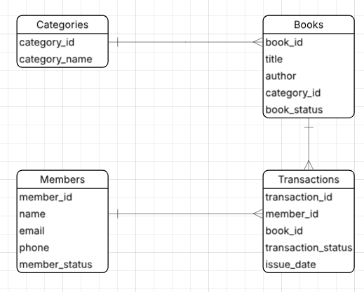
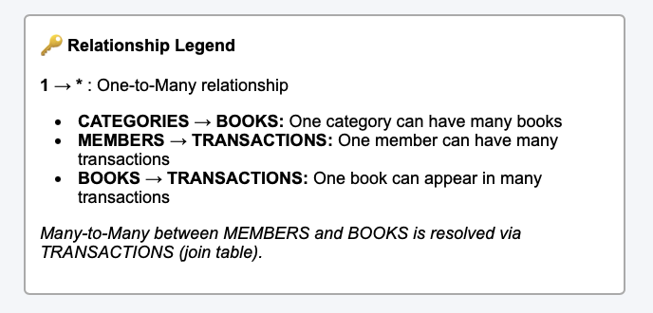

Table Structure

1. Books Table Structure with Sample Data

Field Name | Description | Data Type | Sample Value 1 | Sample Value 2 | Sample Value 3
book_id | Unique book identifier | VARCHAR(10) PRIMARY KEY | BK001 | BK002 | BK003
title | Book title | VARCHAR(200) NOT NULL | Introduction to Algorithms | Learning Python | Database Systems
author | Author name(s) | VARCHAR(100) NOT NULL | Thomas H. Cormen | Mark Lutz | Raghu Ramakrishnan
category_id | Reference to Categories table | VARCHAR(10) FOREIGN KEY | CAT001 | CAT002 | CAT003
book_status | Book status | VARCHAR(20) NOT NULL | Issued | Available | Deleted
Field Type Notes:
- book_id: System generated, Read Only
- title: User Input, Mandatory
- author: User Input, Mandatory
- category_id: User Input (selected from Categories), Mandatory
- book_status: User Input (updated while books are added or removed from circulation), Mandatory

2. Members Table Structure with Sample Data
Field Name | Description | Data Type | Sample Value 1 | Sample Value 2 | Sample Value 3
Member_  id | Unique member identifier | VARCHAR(10) PRIMARY KEY | MEM001 | MEM002 | MEM003
name | Member's full name | VARCHAR(100) NOT NULL | Rajesh Kumar | Priya Sharma | Amit Patel
email | Email address | VARCHAR(100) UNIQUE NOT NULL | rajesh.kumar@email.com | priya.sharma@email.com | amit.patel@email.com
phone | Contact number | VARCHAR(15) NOT NULL | 9876543210 | 9123456789 | 9988776655
Member_status | Status of the members | VARCHAR(20) NOT NULL | Active | Inactive | Deleted
Field Type Notes:
- member_id: System generated, Read Only
- name: User Input, Mandatory
- email: User Input, Mandatory, Must be unique
- phone: User Input, Mandatory
- member_status: User Input, Mandatory

3. Transactions Table (Join Table) Structure with Sample Data

Field Name | Description | Data Type | Sample Value 1 | Sample Value 2 | Sample Value 3
transaction_id | Unique transaction identifier | VARCHAR(10) PRIMARY KEY | TXN001 | TXN002 | TXN003
member_id | Foreign Key to Members table | VARCHAR(10) FOREIGN KEY | MEM001 | MEM002 | MEM001
book_id | Foreign Key to Books table | VARCHAR(10) FOREIGN KEY | BK001 | BK002 | BK003
issue_date | Date book was issued | DATE NOT NULL | 2024-09-15 | 2024-09-18 | 2024-09-20
transaction_status | Status of the book | VARCHAR(20) | Issued | Available | Deleted

Note: This is a join table that links Members and Books tables, tracking all borrowing activities.
- transaction_id: System generated, Read Only
- member_id: Foreign Key, Selected from Members table, Mandatory
- book_id: Foreign Key, Selected from Books table, Mandatory
- issue_date: System generated (current date), Read Only
- transaction_status: status of the book, Mandatory

4. Categories Table Structure with Sample Data
Field Name | Description | Data Type | Sample Value 1 | Sample Value 2 | Sample Value 3
category_id | Unique category identifier | VARCHAR(10) PRIMARY KEY | CAT001 | CAT002 | CAT003
category_name | Name of category | VARCHAR(50) UNIQUE NOT NULL | Computer Science | Programming | Database

Sample Records:
CAT001 | Computer Science
CAT002 | Programming
CAT003 | Database
CAT004 | Mathematics
CAT005 | Web Development

Field Type Notes:
- category_id: System generated, Read Only
- category_name: User Input, Mandatory, Must be unique

Key Features Implementation

Business Rules
- Borrowing Period: Standard borrowing period is 14 days (calculated as issue_date + 14)
- Maximum Books: Students can borrow up to 3 books, Faculty up to 5 books (enforced in application logic)
- Late Fee: ₹5 per day for overdue books (calculated in application)
- Book Availability: Tracked by transaction status of the book
- Member Activity: Current borrowed books counted through transaction status

Validation Rules
- Member must exist in Members table to borrow books
- Book must exist in Books table to be issued
- Member cannot borrow the same book multiple times simultaneously
- Email must be unique for each member
- Category must exist before assigning books to it

Status Values (Managed in Application Logic)
- Book Status: Active, Inactive, Lost, Under Maintenance
- Member Status: Active, Inactive, Suspended, Expired
- Transaction Status: Issued, Returned, Overdue, Lost
- Category Status: Active, Inactive

Welcome Screen Design

Admin Welcome Screen
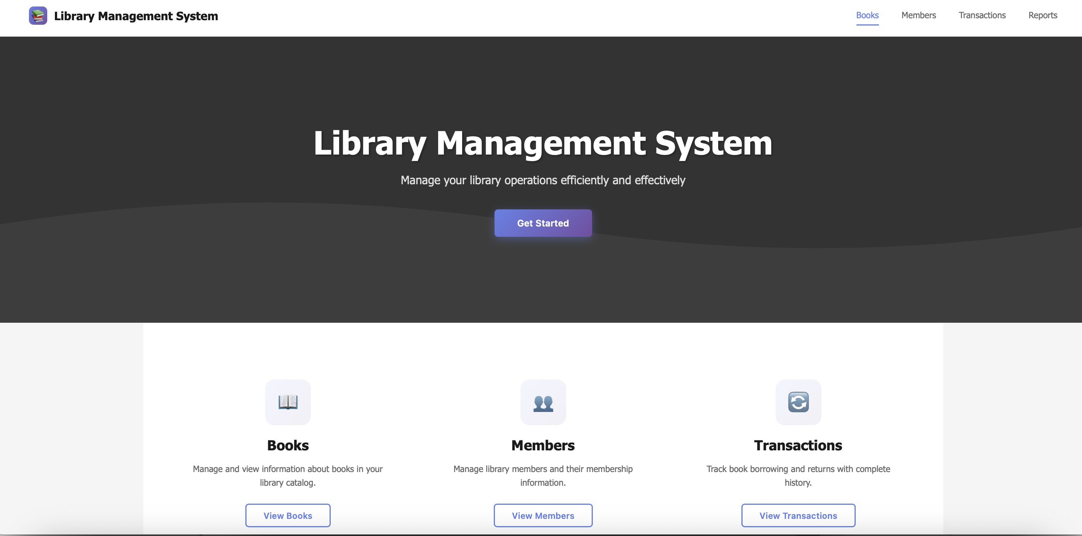

Member Welcome Screen
